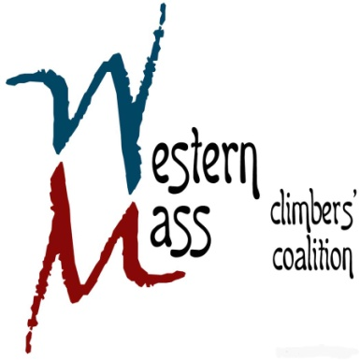

**1st Quarterly Meeting Agenda**

**Thursday February 26th, 2015 / 7:05 PM / CRG Hadley**

**Financials (15 mins)**

* Current standing
* Membership update

**Silent Auction (30 mins)**

* Pre-event planning
* Delegating responsibilities
* Other

**Farley Project Update (15 mins)**

* AMC/NET trail preservation project

**Access (15 mins)**

* Future projects update

**Remaining items? (15 mins)**